Reflection
- What did you ask the AI coding tool to do? Give one specific example of a prompt you used and what it produced.
I used Cursor to generate the code based on step-by-step instructions I gave it. I almost didn't write my own code but reviewed and corrected when needed.
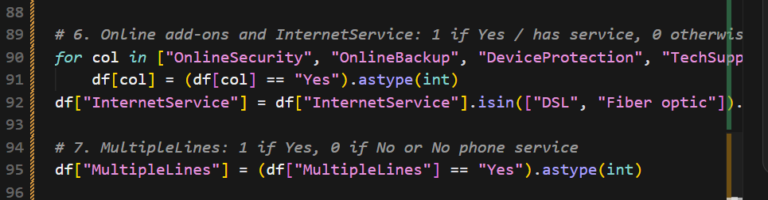
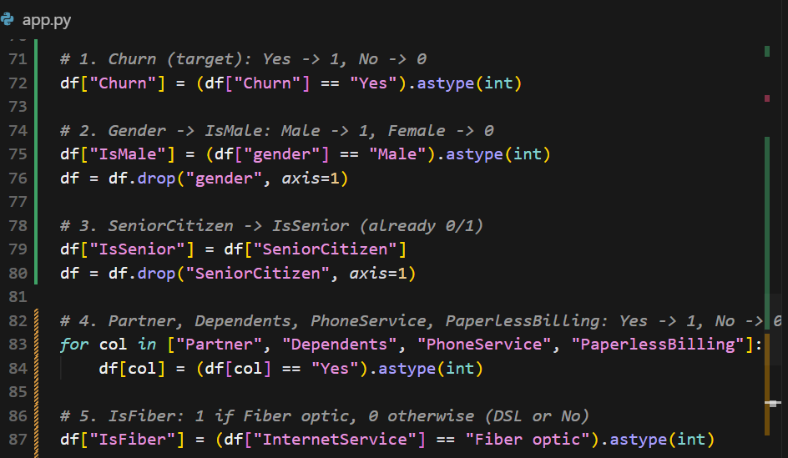
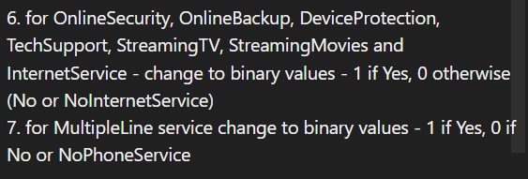
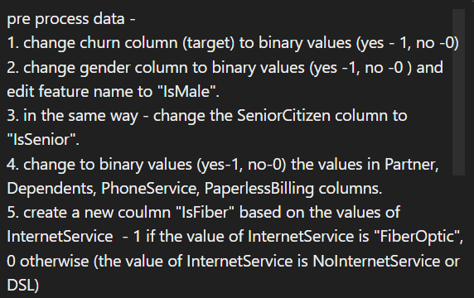
For example – when preprocessing the dataset, I provided a detailed, explicitly formatted prompt instructing the model on how to clean and encode each specific feature:

- What did the tool do well? Where did it struggle, hallucinate, or produce incorrect DS code?
It did well when given detailed instructions, struggled when given high-level or ambiguous requests and didn’t get sufficient data about how exactly to do so. For the above prompt for example, I first asked it to encode the categorical features and got one-hot encoding for all of them, resulting in a lot of new dummies features.
Also, I found the code generated not organized sufficient enough, as it didn’t divide into sections or used functions on its own (another thing I should have instructed specifically).

- What is one key takeaway about using AI assistance in a data science workflow specifically?
As a first-time user of AI coding tools, this was a highly insightful learning experience. My primary takeaway is to first thoroughly understand the dataset and design the pipeline logic myself and only then break it to well informed and specific instructions.

